**How the query optimizer estimates the statistics in a query with AND’ed and OR’ed predicate?**

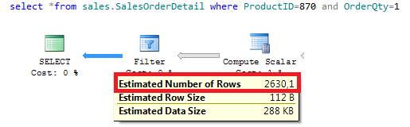

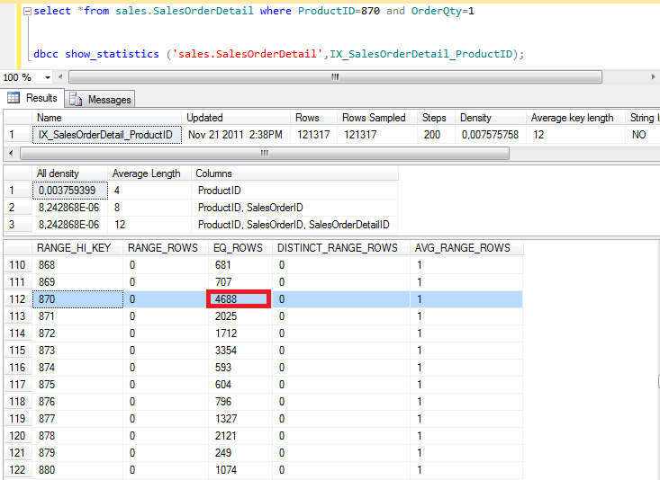

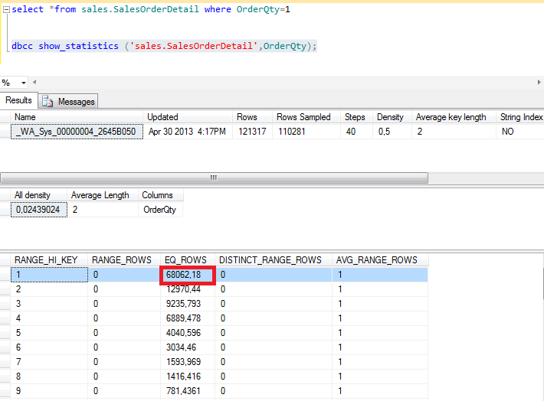

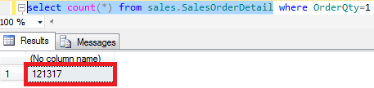

Select 46.888/121.317 = 0.3864915881

select 68.062/121.317 = 0.5610260721



SELECT 0.3864915881*0.5610260721*121.317 = **26.30**539046499367095354717

Now, I’m gonna change the predicate to Or:

select *from sales.SalesOrderDetail where ProductID=870 or OrderQty=1

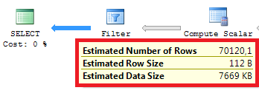

The arithmetic formula is: 4688 + 68062.18 – 2630.10 = 70120.1 (70.120,08)